FOOD ORDER COST &
PROFIT ANALYSIS,
Prepared By,
Ayoola Enoch Ayo-oni,
Wetin Dey Code Academy,
June, 2026.

- Outline:
- Introduction
- Data Source and Overview
- Objectives
- Data Cleaning and Transformation
- Data Analysis and Insights
- Visualization
- Conclusion
- Recommendations

- . Introduction
Food Delivery Cost and Profitability Analysis is a comprehensive evaluation aimed at understanding and optimizing the financial dynamic of a food delivery operation. The goal is to identify areas where the service can reduce costs, increase revenue, and implement pricing or commission strategies that enhance profitability.
This analysis examines food delivery order data to evaluate cost structures, profitability, delivery performance and efficiency across a food ordering platform. The report covers 1,000 transactions recorded between January and February 2024.
Purpose and Scope

Stakeholders who benefit from this analysis include:
- Operations teams: to optimize delivery fees and discount strategies
- Finance teams: to track commission income vs. processing costs
- Marketing teams: to evaluate the ROI of discount and promo campaigns

- Data Source and Overview
The dataset used for this analysis was gotten from the Kaggle.com website. It contains 1001 rows and 12 columns. The dataset includes the following fields:
- Order Id
- Customer Id
- Restaurant Id
- Order Date and Time
- Delivery Date and Time
- Order Value
- Delivery Fee
- Payment Method
- Discounts and Offers
- Commission Fee
- Payment Processing Fee
- Refunds/Chargebacks

Data Limitations

- No product category data: we cannot tell what food types drive higher values
- No geographic data: cannot assess regional delivery patterns
- Date range is short (38 days): findings may not represent seasonal trends
- Locked Data set: As such, I could not replace certain sets of data

- Objectives
- Analyze delivery performance and efficiency across payment methods and order values
- Assess revenue, costs, and profitability by payment method
- Evaluate the impact of discount types on order value and refund rates
- Examine processing fee costs across different payment channels

- Data Cleaning Process
- Blank Space Detection and Replacement: I checked for blank cells using the New Formatting Rule option under Conditional Formatting in the Home tab. I checked for blanks using the find and replace functions, No blanks were discovered and filled.
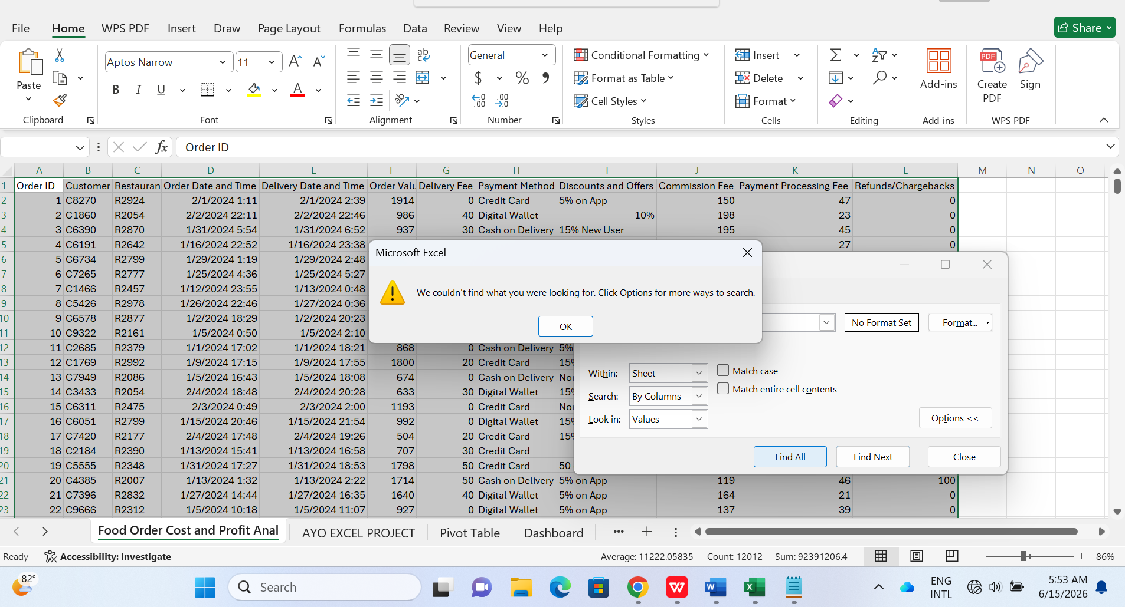

- Duplicate Check and Removal: I checked the dataset for duplicate records using the Remove Duplicates feature in the Data tab. No duplicate records were found nor removed from the dataset. 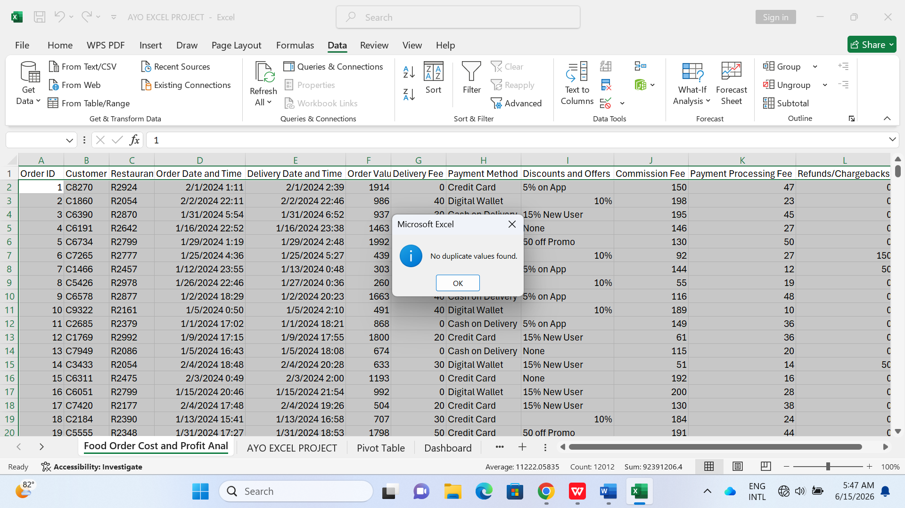

- Format Order Date column : Column D and E was in the mm/dd/yyyy format
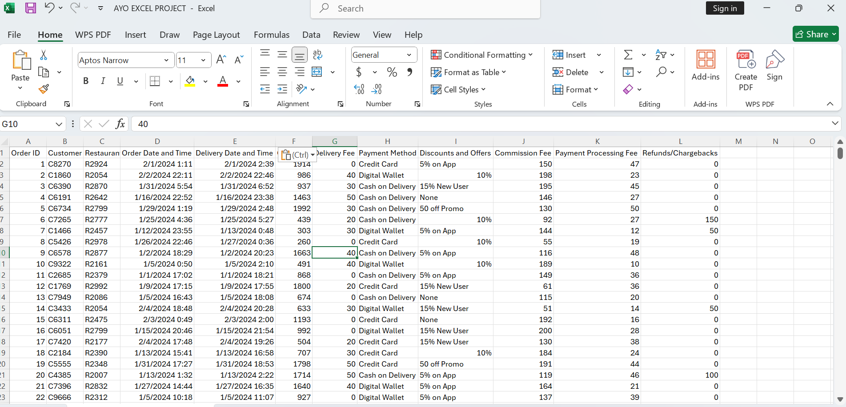

The Columns were in Column D and E (Order Date and Time, Delivery date and time) were then formatted to dd/mm/yyyy using the custom format

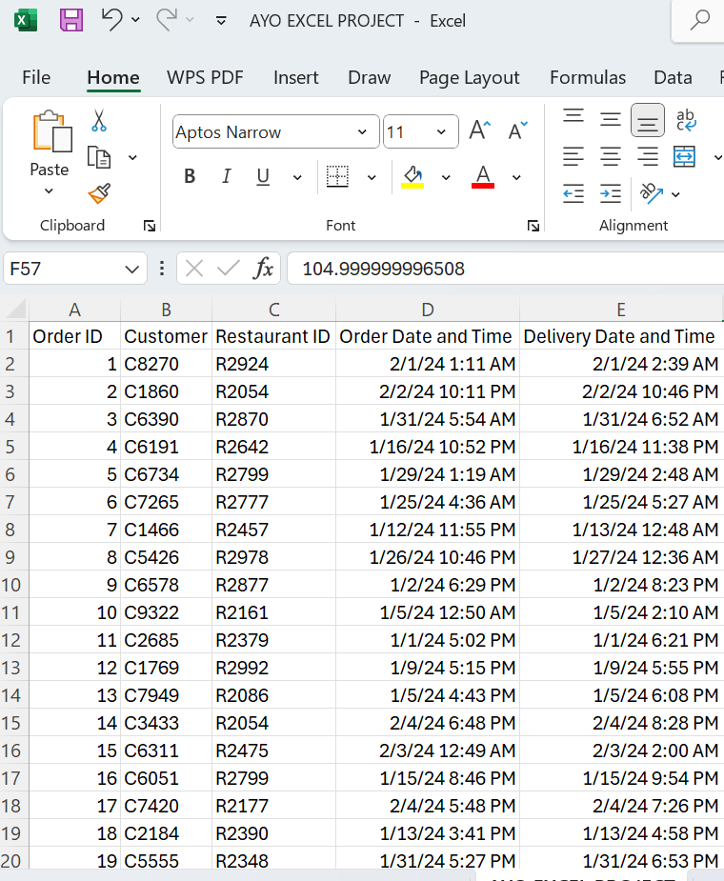

- Format Currency Columns
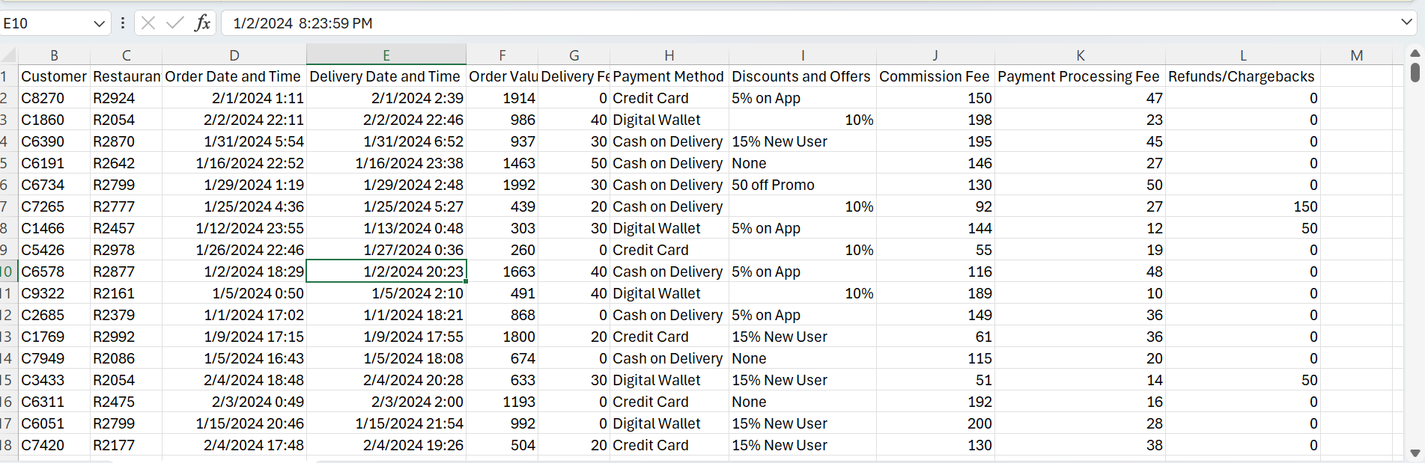
Select the columns that are currency related and format them using the currency format option
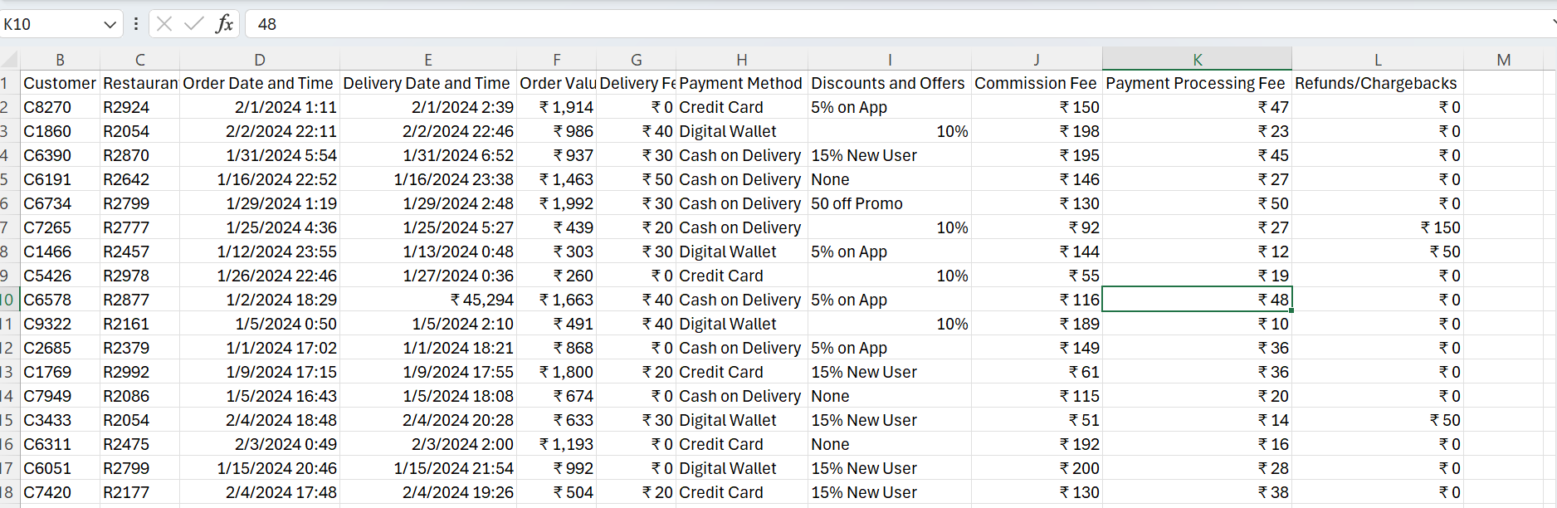

- Add an extra column named “Delivery Time (minutes)” to calculate the time it takes for an order to be made and delivered. By subtracting the Delivery Date and Time from the Order date and time (E2-D2) and converting it to minutes
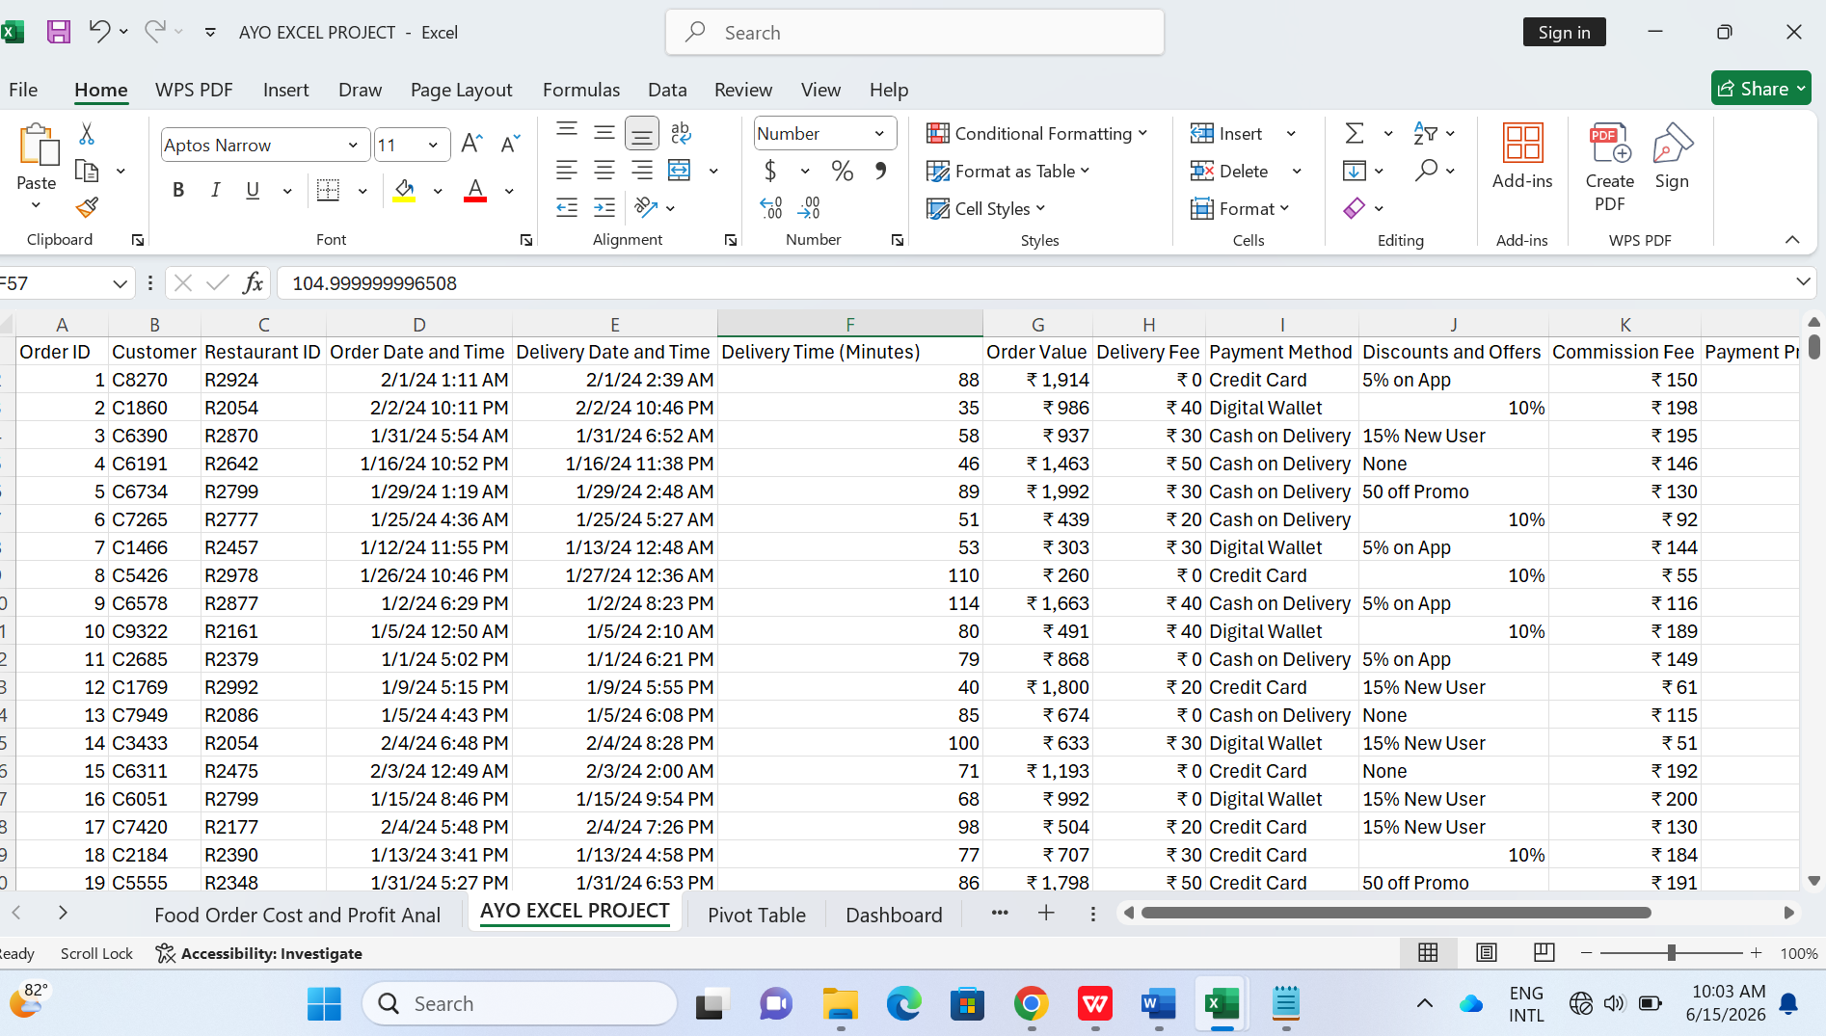

- Data Analysis and Insights
Analysis
- 1st Objective: Analyze delivery performance and efficiency
- Top 10 Average delivery time

- Delivery times with highest refunds.

- Payment method with highest delivery fee

- 2nd Objective: Assess Revenue, Costs, and Profitability

- Compare payment methods and their contribution to sales

- Examine the contribution of discounts and offers on order value

- To calculate the cost of processing fees per payment method

Insights
1st Objective:
Analyze delivery performance and efficiency

- The chart showing the Top 10 Average delivery time shows that in total, the order value with the highest delivery time is 335 Rupees and 1513 Rupees. While the order value with the lowest delivery time is 269 Rupees and 811 Rupees.

- The chart showing the delivery times by highest refunds shows that order value is not proportional to delivery time.

- The chart showing Payment method by delivery fee shows that in total, Cash on delivery charged the highest for delivery fee which is 10,050 Rupees. While in total, digital wallet charged the lowest for delivery fee with the sum of 8,760 Rupees

2nd Objective:
Assess Revenue, Costs, and Profitability

- The chart comparing payment methods and their contribution to sales shows that cash on delivery brings in the highest in terms of order values with 374,669 Rupees. While digital wallet brings in the lowest in the terms of order value with 318,092 Rupees

- The chart showing the comparing discounts and refunds/chargebacks shows that the 10% discount brings in the highest in terms of total order value with 245,525 Rupees while the No discount brings in the least in terms of total order value with 193,857 Rupees

- The chart showing the cost of processing fees per payment method shows that in total, cash on delivery costs the highest with 10,704 Rupees in processing fees. While the digital wallet costs the lowest in total with 9,056 Rupees

- Visualization
  - Delivery performance and efficiency
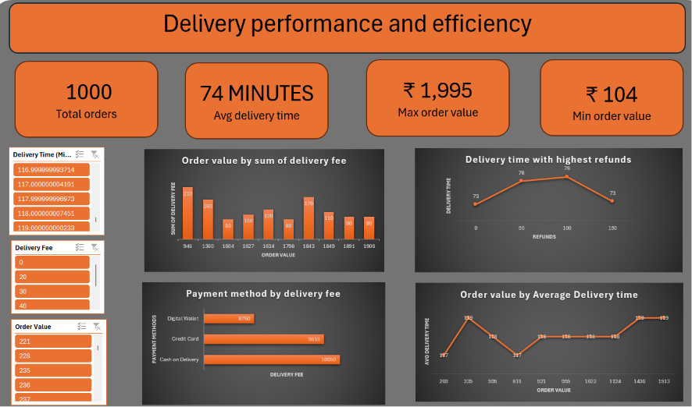

2.Assess Revenue, Costs, and Profitability
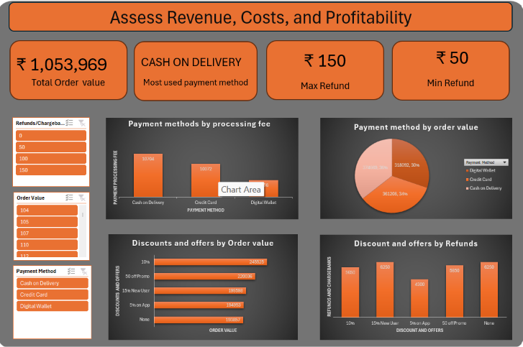

- Conclusion
The food order cost and profit analysis data has the highest delivery fee of 248 Rupees with the order value as 948 Rupees and the total cash on delivery payment method has 10,050 Rupees

The analysis also shows that orders that cost 335 Rupees and 1513 Rupees take longer to deliver with 119 minutes. While orders that take 39 minutes and 116 minutes costs the company the highest in terms of refunds with 550 Rupees each

The analysis shows that the cash on delivery method was used by most people, bringing in 36% of the order values. Although it costs more in terms of processing fee with 10,704 Rupees.

The analysis also shows that the 10% discount contributes to the highest in terms of order value. The no discount offer and 15% new user contributes to the highest in terms of refunds, each contributing to a loss of 6250 Rupees in refunds/ chargebacks

- Recommendations
1. Encourage Digital Payment Methods
- Offer a small loyalty bonus (e.g., 20 cashback) for Digital Wallet payments in order to add volume to Cash on Delivery. This will boost the Digital payments method.
2. Investigate High Refund Orders
- A further analysis can be performed to investigate the reason for the high refund orders to find the root cause. By reducing the refunds, this would increase the revenue of the restaurants
3.Discontinue ineffective discount
- Based on the analysis, the 15% new user discount should be discontinued as it has a high refund rate
4. High-value low-speed orders
- Certain high value orders have low delivery speed. The restaurants should consider other options to ensure fast delivery speed

Implementing these recommendations will help the restaurants reduce refund rates and increase patronage and drive traffic to their digital wallets

Contact details;
Email: ayoolaoni09@gmail.com
Phone: 07036127122

